Detection of Covid-19 using ResNet50 and VGG16 in Convolution Neural Network
M.Shanmuga Sundari1 , Tetali Varshitha², Mekkina Krishnaveni², L.V.Navya sree2

1 Assistant Professor, BVRIT HYDERABAD College Of Engineering For Women , Nizampet Road, Bachupally,Hyderabad-500090 Telangana, India.
2 Student, BVRIT HYDERABAD College Of Engineering For Women , Nizampet Road, Bachupally,Hyderabad-500090 Telangana, India.

sundari.m@bvrithyderabad.edu.in ,18wh1a0570@bvrithyderabad.edu.in, 18wh1a0581@bvrithyderabad.edu.in, 18wh1a0583@bvrithyderabad.edu.in
Abstract. A novel coronavirus (CoV) generally known as ‘SARS-CoV2’ or ‘2019 novel coronavirus’ or ‘COVID-19’ by the WHO which is the outbreak of pneumonia that started at the beginning of 2019 in December in China. COVID-19 is a contagious virus. As COVID-19 is a contiguous disease, early detection of the virus is very important but it can be incurable if the virus is detected later. The identification of COVID-19 disease is done by collecting samples from the throat and nose, which is susceptible to errors which are made by humans. This research proposed a system for identification of the virus utilizing X-Ray images. Dataset used consists of both Covid and Normal X-ray images. Among Convolutional Neural Network(CNN) models, the proposed models are ResNet50 and VGG16. RESNET50 consists of 48 convolutional, 1 MaxPool and Average Pool layers and VGG16 is another convolutional neural network that consists of deep 16 layers. By using these two models detection of COVID-19 is done. This research can be practically helpful to the physicians with the usage of datasets for the successful diagnosis of COVID-19 disease in the medical field.
Keywords: CNN(Convolutional Neural Network), ResNet50(Residual Network), VGG16(Visual Geometry Group).
1 Introduction
COVID-19 is a pathogenic disease caused by SARS-CoV-2. The first case was found in Wuhan city, China in December 2019. As of March 11, WHO declared Covid 19 a pandemic caused by a coronavirus. Covid-19 symptoms include fever, headache, cough, breathing difficulties, and it leads to loss of smell and taste. These signs live in the human body between 1 to 14 days after being subjected to the virus.
Early discovery of COVID-19 is very crucial for organizing treatments and keeping track of the patients. The automatic detection of the COVID-19 virus from photographs is a critical component of the next generation of computer-assisted diagnostic and other technologies. The human chest X-rays were mostly utilized as visualizing methods for the identification, categorizing and complete study of the virus.

Artificial intelligence and sub-branches aimed at designing intelligent systems with human thinking and decision-making capabilities have always piqued the curiosity of researchers. According to this study, Convolutional Neural Networks (CNN) are one of the most essential and fundamental architectural models in machine learning. They are widely used for image classification, face recognition, scene labeling, object detections, medical image processing and disease diagnosis etc. CNN operates directly on the images rather than concentrating on feature extraction which is done by other neural networks.
In this study, a method was developed that uses human chest X-ray scan findings and CNN to determine whether or not a person is infected. In this research from CNN, ResNet and VGG models are used. ResNet50 is a convolutional neural network with a depth of 50 layers. It can classify up to 1000 different types of objects such as “keyboard, mouse, pencil, and many animals”. ResNet50 is one among the ResNet models which has 48 Convolutional, 1 MaxPool and 1 Average Pool layer. It consists of 3.8 x 10^9 Floating points operations.
The VGG model stands for Visual Geometry Group. The VGG16 is a form of 16-layer convolutional neural network. It is one of the most widely used picture categorization and detection methods. The VGG16 model has a total of 16 layers. The 16 in VGG16 stands for 16 weighted layers. In VGG16, there are a total of 21 layers, divided into thirteen convolution, five Max Pooling, and three Dense layers, but only sixteen weighted layers with learnable parameters. One of the most distinguishing elements of VGG16 is that, rather than having a huge number of hyper-parameters, they focused on having 3x3 filter convolution layers with stride 1 and always used the same padding and maxpool layer of 2x2 filter stride2.
The exploration of this study initially has shown promising outcomes in terms of its performance parameters in order to detect the disease in a cost-time efficient manner. To train the CNN models that are Resnet50 and VGG16 , a dataset “COVID-19 Radiography Database” has been taken from Kaggle. In order to make the training features of the model accurate and to increase the limited-size of a dataset, data augmentation steps can be performed. After complete data augmentation, the CNN model has been trained with the images of the dataset and then the model has been tested by using a test set. Later, the CNN model performance evaluation has been done using different performance metrics and measures.
2 Literature Survey
In [1] this paper, the authors have worked on the CNN model and came up with the detection of COVID-19 virus utilizing COVID-19 Radiography dataset from Kaggle. They used ReLU as the activation function and a Softmax classifier which builds end predictions of the disease. This CNN model has a 99.20 percent accuracy in determining if a patient's chest X-ray image has COVID-19 or not. The authors in [2] have attempted a system for identification of the Coronavirus infected images of human chest X-Ray using CNN model. Local binary patterns(LBP) are used for extracting features and classifiers used are “K-Nearest Neighbors(KNN), Naive Bayes(NB), Random Trees and Random Forests, Support Vector Machine(SVM).” Here, the proposed method uses a dataset which has human chest X-Rays of non infected people as well as patients suffering from pneumonia and Covid19 virus infection.

In [3], the authors have proposed a deep transfer learning-based model that improves the current accuracy. They worked on COVID-19 Radiography dataset from Kaggle. The multiple CNN models are used like ”AlexNet, VGG, SqueezeNet, GoogleNet”. The DenseNet121 and ResNet50 are the two networks which are fine-tuned with the deep classifiers such as “Support vector machine (SVM), random forest, K-Nearest neighbor (KNN), and CNN with softmax classifier” with data augmentation to detect three classes of COVID-19 ,Viral Pneumonia and normal radiographs. This model shows an accuracy of 97.83%. In [4] ,The authors used radiology which helps to diagnose patients carrying coronavirus symptoms . They worked on the dataset taking two different sources. The first is Covid-chestxray-dataset which consists of covid-positive X-Ray images and second source is ChestX-ray8 database which consists of X-Rays of normal and pneumonia-infected people. Here, they used concepts of CNN as the model and resulted an accuracy of 87%.

In this paper[5], the author presents an examination of the Convolutional Neural Network(CNN) for the classification of COVID-19 and normal patients. Binary classification was carried out, with Sigmoid as the classifier and Binary-Cross Entropy as the loss function. It focuses on comparing APST-Net to CNN's pre-trained models, as well as combining different epochs with different optimizers that can be used to design other image processing approaches. The 2 datasets used here for this research are Chest X-Ray Images(Pneumonia) from Kaggle and another is “covid-chestxray-dataset” from GitHub. The greatest training, validation, and F1-scores are 98.45 percent, 98.20 percent, and 98.18 percent for APST-Net trained using Adam optimizer. In [6], the authors have proposed the tensor flow based CNN method which is used to classify chest x-ray images. They used datasets like “Covid-chestxray-dataset and Chest X-Ray Images (Pneumonia)”. The performance of the CNN model is a helpful tool for radiologists for COVID-19 classification and detection. This approach with RELM will help the researchers for further analysis. This model shows the accuracy of 95%.

In [7], the authors used datasets like “Covid-chestxray-dataset and Chest X-Ray Images (Pneumonia)”. They worked on “Detection And Spread Prediction Using CNN-GMM(Gaussian Mixture Model)”. The GMM-based linear regression successfully predicts the disease using the parameters like mean and covariance of the distribution. The model shows the accuracy of 96.6%. In [8], the authors used X-Ray and SARS-CoV-2 CT scan datasets. They proposed a deep learning model using Transfer learning to detect COVID-19. The developed approach consisted of DenseNet and InceptionV3 models by at least 12 percent, which explains the feasibility and effectiveness of the proposal. Both X-ray and CT scans were considered to estimate the proposed methods.

In [9], authors included a total of 657 chest X-ray images which have been taken for the diagnosis of COVID-19 using deep learning methods like CNN, VGG16, VGG19, and InceptionV3. Here, Softmax Classifier is used and Relu is taken as the activation function. COVID-19, healthy patients, and viral pneumonia cases are classified successfully by the VGG19 model that has a 95% accuracy rate. InceptionV3 is the most doomed(unsuccessful) method for the dataset. In [10] this paper, Coronavirus infection was detected using a database of X-ray and CT-Scan pictures with pneumonia, Covid-19 infection, and common cases. They have used ResNet50, Inception V3 and Inception-ResNetV2 pre-trained models to obtain high accuracy for small X-ray databases. Test results obtained from the chest X-ray and CT dataset show features obtained from DenseNet 121 and later trained by the Bagging tree classifier. This produces accurate predictions of 99.00%.

3 Dataset
Since, COVID 19 is a new type of virus, the detection of the virus is still being refined. This research is significant since numerous X-ray scans are utilized to detect viruses. The dataset utilized in this research is called “COVID-19 Radiography Database” which is collected from kaggle. A total of 3616 COVID-19 images, 6012 lung opacity images, 10.2k normal images and 1345 viral pneumonia images are prepared. Data cleaning is performed by feature extraction and detection is done using two models that are Resnet50 and VGG16. Later training and testing are performed on these CNN models. The dataset used in this paper is generally accessible.
2.1 Data Pre-processing
The height and width of the X-ray images of the human chest in the dataset are 299 pixels. In the pre-processing, images are classified into covid and normal. To begin pre-processing, we need to acquire the data from kaggle i.e COVID-19 Radiography Database, later import the dataset into the project, differentiating covid and normal images, and before the implementation we need to normalize the dataset.
2.2 Data Cleaning
Data cleaning is the process of removing extraneous or inaccurate information from data prior to analysis. Data cleaning includes not only the removal of redundant data, but also the correction of inaccurate information. Inaccurate and inadequately collected datasets might also cause models to develop incorrect representations of the data, limiting their decision-making abilities. Duplicate images are removed from the dataset using data cleaning. This procedure will aid in maintaining image accuracy and uniformity.

3 Architecture

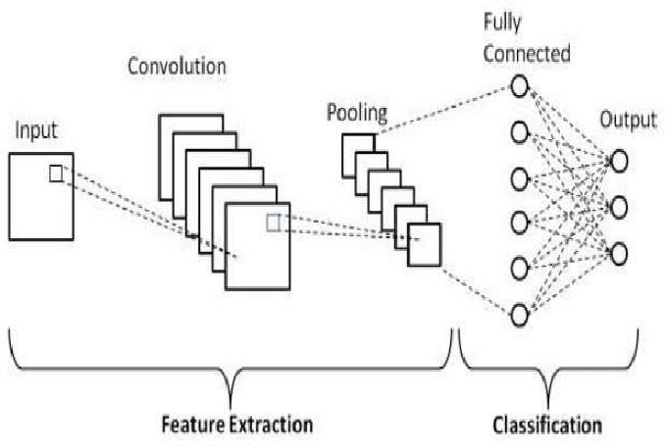

Fig.1. Architecture

The goal of this study is to use human chest X-ray pictures to determine if a patient is COVID-19 affected or not. In the architecture, initially, the images are given as input to the CNN model which is already trained using a dataset which contains images of human chest X-rays. In convolution, filters are applied to the input images that result in activation. The pooling layers makes the model more robust. The "input images", "convolution" and "pooling" steps come under feature extraction. "Fully connected" and "output" steps come under classification. All of the inputs from one layer are coupled to every activation unit of the next layer in fully connected neural networks. Finally, we get the result.
4 Implementation
In this research, a CNN architecture ResNet50 and VGG16 are designed for the Covid-19 virus detection. These models are used to determine if a patient has COVID-19 or not based on a chest X-ray scan. The partitioning process in the dataset is considered for a thorough training. We partitioned the complete dataset into three sets: train, validation, and test, each comprising 7800, 1008, and 800 images. When it comes to data augmentation, every image in the training set is enlarged to 224x224 pixels. Later, color jittering of images is done for training and validation sets in which black and white images are converted into RGB format for better visualization. The training set images are randomly cropped and rotated but, for the validation set, all images were just normalized. After resizing the image, the test set which consists of raw images is given to the trained model.
4.1 ResNet50 Model
In this research the first used model is the “ResNet50” model. This model is made up of five stages, each with three convolution layers and a convolution and identity block. The input shape taken in this model is (224,224,3) only if include_top is False. It should have exactly three input channels and a width and height of 32 pixels. Here, include_top will consider the new weights. Later, “Flattening” of layers is done in order to convert it into a 1D array which acts as an input for the next layer. In addition, each neuron in the "Dense layer" receives input data from all other neurons in the previous layers. Here, “Sigmoid '' is taken as an activation function and “Adam” is used as an optimizer.

Plotting of 2 graphs is done i.e one is accuracy vs. validation accuracy and other is loss vs. validation loss. Here, accuracy(acc) and a loss are represented in red and validation accuracy(v-acc) and validation loss(v-loss) is represented in blue color.
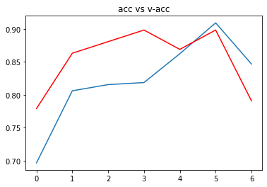 | 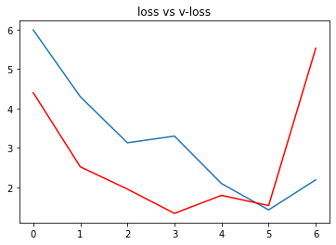

Fig.2. acc vs v-acc Fig.3. loss vs v-loss
The accuracy of the entire model is 88%. Later, the image path is given as input and a pre-processed image is obtained as output(Figure-4). The type of X-ray image in Figure-4 is detected as “Covid” and the chances of being covid or normal is also detected.
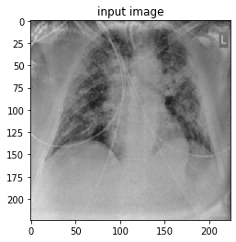
Fig.4. Input image(Covid)
4.2 VGG16 Model
In this research the second used model is the “VGG16” model.VGG16 has 138 million parameters in total. The name VGG16 refers to the fact that it has 16 layers of varying weights. This is a large network. VGG-16 employs 13 convolutional layers and three fully linked layers in its architecture. The crucial thing to remember is that all conv kernels are 3x3, while maxpool kernels are 2x2 with a stride of two.
The input shape taken in this model is (224, 224, 3). It should have exactly three input channels and a width and height of 32 pixels. After that, the parameters are not retrained. Later, the layers are "flattened" to convert them to a 1-D array, which is then entered into the following layer. In addition, each neuron receives input data from all other neurons in the previous layers in a "Dense layer." As an activation function, "Sigmoid '' is used here.

Plotting of 2 graphs is done i.e one is accuracy vs. validation accuracy and other is loss vs. validation loss. Here, accuracy(acc) is represented in red and validation accuracy(v-acc) is represented in blue color. The loss is represented in red and validation loss(v-loss) is represented in blue color.

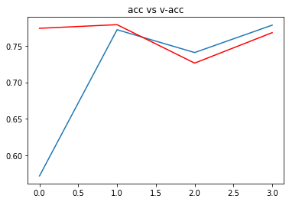 | 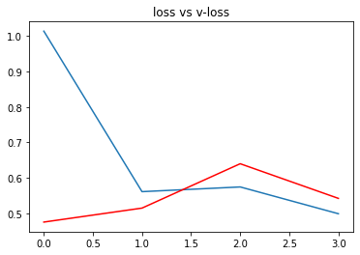

Fig.5. acc vs v-acc Fig.6. loss vs v-loss
The accuracy of the entire model is 85%. Later, the image path is given as input and a pre-processed image is obtained as output(Figure-7). The type of X-ray image in Figure-7 is detected as “Covid” and the chances of being covid or normal is also detected.
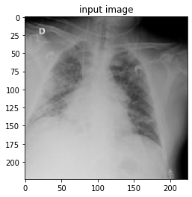
Fig.7. Input image(Covid)

Further, “Grad CAM Visualization'' is performed where Grad-CAM is a technique for constructing a class-specific heat map based on a specified input image, a trained CNN, and a chosen class of interest. Grad CAM Visualization aids in the comprehension of image categorization, captioning, and visual question answering (VQA) models. We will also normalize the heatmap between 0 & 1 for visualization purposes. Heatmap is a 2-D representation of information with the help of colors and it helps the user to visualize simple or complex information.
5 Results
The CNN model is implemented by separating all of the data into three sets: training, validation, and testing. Figures 2 and 3 for ResNet50 and Figures 5 and 6 for VGG16 show the accuracy and loss graphs for the identification of COVID-19 picture vs Normal image. The CNN model ResNet50 obtains an overall accuracy of 88% for COVID-19 detection whereas VGG16 model obtains an accuracy of 85%. The image path is given as input and a pre-processed image(original image) is obtained as output for Figure-4 and Figure-7. In ResNet50 the type of X-ray image in Figure-8 and Figure-9 are detected as “Covid”, “Normal” and the chances of being covid or normal is also detected. Later the image with a heatmap representing the region of interest is also done. In VGG16 the type of X-ray image in Figure-10 and Figure-11 are detected as “Covid”, “Normal” and the chances of being covid or normal is also detected. Later the image with a heatmap representing the region of interest is also done.

5.1 ResNet50

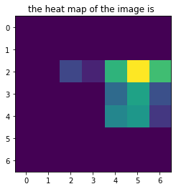 | 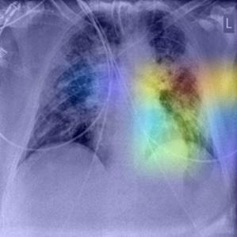 | 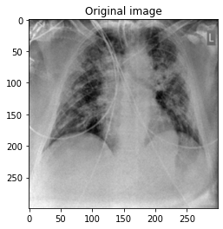

Fig.8. (i)Heat map of the image, (ii) Image with heatmap representing region on interest, (iii) Original input image(For Covid)

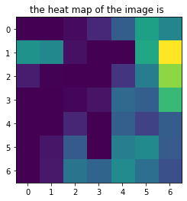 | 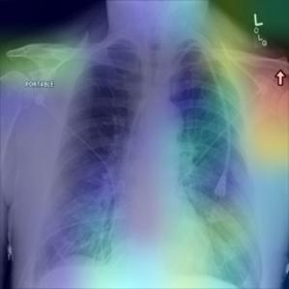 | 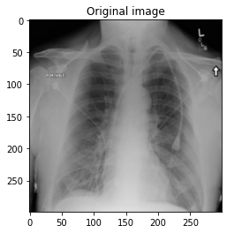

Fig.9. (i)Heat map of the image, (ii) Image with heatmap representing region on interest, (iii) Original input image(For Normal)

5.2 VGG16

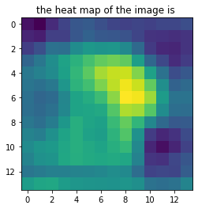 | 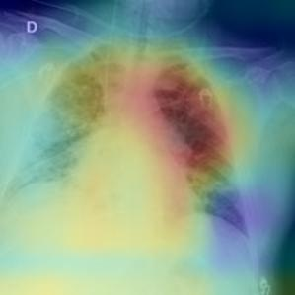 | 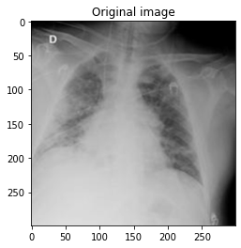

Fig.10. (i)Heat map of the image, (ii) Image with heatmap representing region on interest, (iii) Original input image(For Covid)
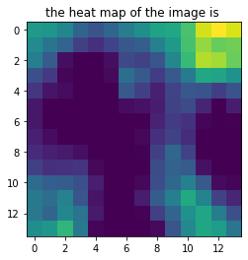 | 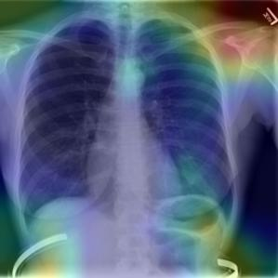 | 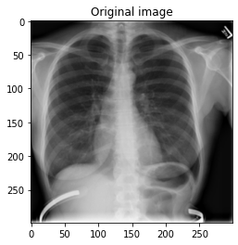

Fig.11. (i)Heat map of the image, (ii) Image with heatmap representing region on interest, (iii) Original input image(For Normal)
6 Conclusion and Future Scope
From the year of 2018, COVID19 has badly affected the global workforce who are at the risk of losing their livelihoods. The paper’s main focus is to implement a machine learning algorithm with help of CNN to detect COVID19 with the help of human chest X-Ray Radiography dataset. Detection of COVID19 is obtained with an overall accuracy of 88% for ResNet50 and 85% for VGG16 model. The proposed system gives a future scope to increase the accuracy of the existing models which will help the physicians in faster identification of the virus and to save numerous lives.

7 References
[1] E. Irmak, "A Novel Deep Convolutional Neural Network Model for COVID-19 Disease Detection," 2020 Medical Technologies Congress (TIPTEKNO), 2020, pp. 1-4, doi: 10.1109/TIPTEKNO50054.2020.9299286.

[2] S. D. Thepade and K. Jadhav, "Covid19 Identification from Chest X-Ray Images using Local Binary Patterns with assorted Machine Learning Classifiers," 2020 IEEE Bombay Section Signature Conference (IBSSC), 2020, pp. 46-51, doi: 10.1109/IBSSC51096.2020.9332158.

[3] Y. Yari, T. V. Nguyen and H. Nguyen, "Accuracy Improvement in Detection of COVID-19 in Chest Radiography," 2020 14th International Conference on Signal Processing and Communication Systems (ICSPCS), 2020, pp. 1-6, doi: 10.1109/ICSPCS50536.2020.9310066.

[4] S. Singh, P. Sapra, A. Garg and D. K. Vishwakarma, "CNN based Covid-aid: Covid 19 Detection using Chest X-ray," 2021 5th International Conference on Computing Methodologies and Communication (ICCMC), 2021, pp. 1791-1797, doi: 10.1109/ICCMC51019.2021.9418407.

[5] S. Thabasum Aara, A. Pandian K, T. S. Sai Kumar and A. Prabalakshmi, "A Novel Convolutional Neural Network Architecture to Diagnose COVID-19," 2021 3rd International Conference on Signal Processing and Communication (ICPSC), 2021, pp. 595-599, doi: 10.1109/ICSPC51351.2021.9451701.

[6] T. Chakravorti, V. K. Addala and J. S. Verma, "Detection and Classification of COVID 19 using Convolutional Neural Network from Chest X-ray Images," 2021 6th International Conference for Convergence in Technology (I2CT), 2021, pp. 1-6, doi: 10.1109/I2CT51068.2021.9418221.

[7] Y. Khan, P. Khan, S. Kumar, J. Singh and R. M. Hegde, "Detection and Spread Prediction of COVID-19 from Chest X-ray Images using Convolutional Neural Network-Gaussian Mixture Model," 2020 IEEE 17th India Council International Conference (INDICON), 2020, pp. 1-6, doi: 10.1109/INDICON49873.2020.9342159.

[8] M. Berrimi, S. Hamdi, R. Y. Cherif, A. Moussaoui, M. Oussalah and M. Chabane, "COVID-19 detection from Xray and CT scans using transfer learning," 2021 International Conference of Women in Data Science at Taif University (WiDSTaif ), 2021, pp. 1-6, doi: 10.1109/WiDSTaif52235.2021.9430229.

[9] M. Sevi and İ. AYDIN, "COVID-19 Detection Using Deep Learning Methods," 2020 International Conference on Data Analytics for Business and Industry: Way Towards a Sustainable Economy (ICDABI), 2020, pp. 1-6, doi: 10.1109/ICDABI51230.2020.9325626.

[10] A. K. Siddhu, A. Kumar and S. Kundu, "Review Paper for Detection of COVID-19 from Medical Images and/ or Symptoms of Patient using Machine Learning Approaches," 2020 9th International Conference System Modeling and Advancement in Research Trends (SMART), 2020, pp. 39-44, doi:10.1109/SMART50582.2020.9336799.

